EDA Highest Hollywood Grossing Movies

[Films](https://en.wikipedia.org/wiki/Films) generate income from several revenue streams, including [theatrical exhibition](https://en.wikipedia.org/wiki/Movie_theater), [home video](https://en.wikipedia.org/wiki/Home_video), [television broadcast rights](https://en.wikipedia.org/wiki/Broadcasting_rights), and [merchandising](https://en.wikipedia.org/wiki/Merchandising). However, theatrical [box office](https://en.wikipedia.org/wiki/Box_office) earnings are the primary metric for trade publications in assessing the success of a film, mostly because of the availability of the data compared to sales figures for home video and broadcast rights, but also because of historical practice. Included on the list are charts of the top box-office earners (ranked by both the [nominal and real value](https://en.wikipedia.org/wiki/Real_versus_nominal_value_(economics)) of their revenue), a chart of high-grossing films by calendar year, a timeline showing the transition of the highest-grossing film record, and a chart of the highest-grossing film franchises and series. All charts are ranked by international theatrical box-office performance where possible, excluding income derived from home video, broadcasting rights, and merchandise.

1. The number of times distributors have appeared in the top 100.

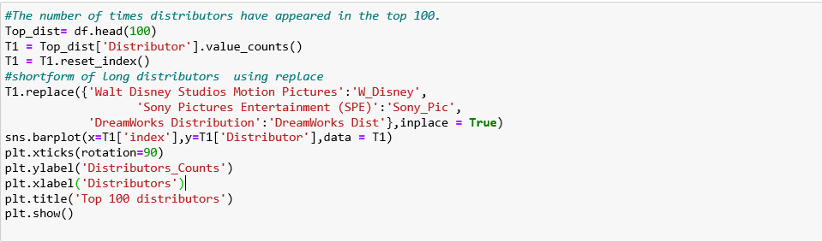

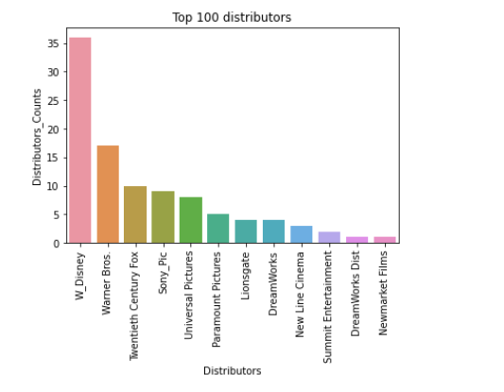

As per above result W_disney means Walt Disney Studios Motion Pictures having maximum distribution count and dream work distributor and Newmarket films having Minimum Distribution count

1. How often do sales occur in each category?

